ОТЧЕТ 9

1. Создание бакета в Yandex Cloud

Вход в Yandex Cloud Console:
Перейдите в Yandex Cloud Console.
Откройте раздел Object Storage.
Создание бакета:
Нажмите "Создать бакет".
Укажите имя (например, nine-test-bucket).
Выберите "Стандартное хранилище" (чтобы избежать платы).
Остальные настройки оставьте по умолчанию.

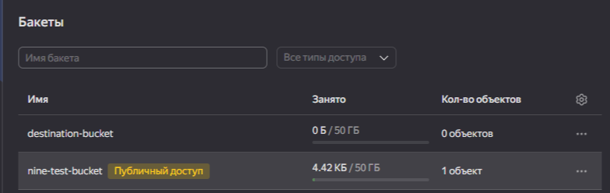

2. Создание сервисного аккаунта (IAM)

Перейдите в раздел "IAM" → "Сервисные аккаунты".
Нажмите "Создать сервисный аккаунт".
Укажите имя (например, s3-access-sa).
Назначьте роль "storage.editor" (для управления хранилищем).
Сохраните секретный ключ (JSON) — он понадобится для аутентификации.

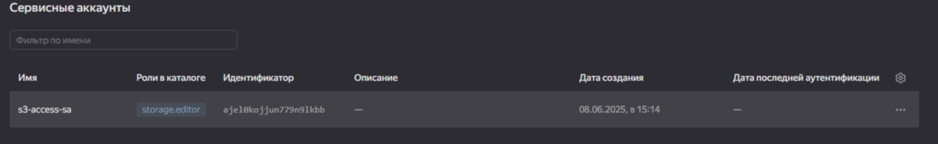

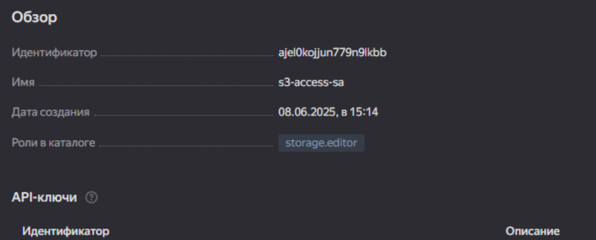
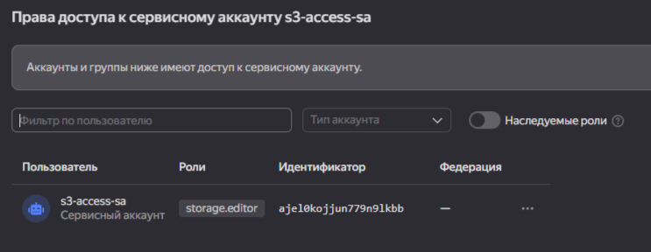

Реализация функции (локально) для выполнения основных операций с объектами в хранилище: получение списка загруженных файлов, загрузка файла в бакет, получение файла, удаление файла.

Код программы

import os
import boto3
from botocore.client import Config
from botocore.exceptions import ClientError
from dotenv import load_dotenv
# Load environment variables from .env file (if it exists)
load_dotenv()
# --- Configuration ---
AWS_ACCESS_KEY_ID = os.getenv('AWS_ACCESS_KEY_ID')
AWS_SECRET_ACCESS_KEY = os.getenv('AWS_SECRET_ACCESS_KEY')
REGION_NAME = os.getenv('REGION_NAME')
ENDPOINT_URL = os.getenv('ENDPOINT_URL')
BUCKET_NAME = os.getenv('BUCKET_NAME')
#Check that all values exits or exit
if not all([AWS_ACCESS_KEY_ID, AWS_SECRET_ACCESS_KEY, REGION_NAME, ENDPOINT_URL, BUCKET_NAME]):
print ("Make sure you .env file is properly setup!")
exit()
# --- S3 Client Initialization ---
try:
s3 = boto3.client(
's3',
endpoint_url=ENDPOINT_URL,
aws_access_key_id=AWS_ACCESS_KEY_ID,
aws_secret_access_key=AWS_SECRET_ACCESS_KEY,
region_name=REGION_NAME,
config=Config(signature_version='s3v4', s3={'addressing_style': 'virtual'}),
use_ssl=False, # Set to True if you're using HTTPS for MinIO (and have a certificate)
verify=False # Set to True if you're using HTTPS for MinIO (and have a certificate)
)
print("S3 client initialized successfully.")
except ClientError as e:
print(f"Error initializing S3 client: {e}")
exit(1) # Exit if the client cannot initialize
# --- Function Definitions ---
def upload_file(file_path, object_name=None):
"""Uploads a file to the bucket."""
if object_name is None:
object_name = os.path.basename(file_path)
try:
with open(file_path, 'rb') as f: # Open in binary mode
s3.upload_fileobj(f, BUCKET_NAME, object_name)
print(f"File '{file_path}' uploaded to '{object_name}' successfully.")
return True
except FileNotFoundError:
print(f"Error: File '{file_path}' not found.")
return False
except ClientError as e:
print(f"Error uploading file: {e}") #Removed detail error which is useless
return False
def list_files():
"""Lists all files in the bucket."""
try:
response = s3.list_objects_v2(Bucket=BUCKET_NAME)
if 'Contents' in response:
print("Files in bucket:")
for obj in response['Contents']:
print(f"- {obj['Key']}")
return [obj['Key'] for obj in response['Contents']]
else:
print("Bucket is empty.")
return []
except ClientError as e:
print(f"Error listing files: {e}") #Removed detail error which is useless
return None
def download_file(object_name, local_path=None):
"""Downloads a file from the bucket."""
if local_path is None:
local_path = object_name
try:
s3.download_file(BUCKET_NAME, object_name, local_path)
print(f"File '{object_name}' downloaded to '{local_path}' successfully.")
return True
except ClientError as e:
print(f"Error downloading file: {e}")#Removed detail error which is useless
return False
def delete_file(object_name):
"""Deletes a file from the bucket."""
try:
s3.delete_object(Bucket=BUCKET_NAME, Key=object_name)
print(f"File '{object_name}' deleted successfully.")
return True
except ClientError as e:
print(f"Error deleting file: {e}")#Removed detail error which is useless
return False
# --- Main ---
if __name__ == "__main__":
TEST_FILE = "test_file.txt"
# Create a test file
try:
with open(TEST_FILE, "w", encoding="utf-8") as f:
f.write("This is a test file for Yandex Object Storage.")
except Exception as e:
print(f"Error creating test file: {e}")
exit(1)
# Demonstrate operations
print("\n1. Uploading file...")
upload_file(TEST_FILE)
print("\n2. Listing files...")
list_files_list = list_files()
print("\n3. Downloading file...")
DOWNLOADED_FILE = "downloaded_" + TEST_FILE
download_file(TEST_FILE, DOWNLOADED_FILE)
print("\n4. Deleting file...")
delete_file(TEST_FILE)
print("\n5. Listing files after deletion...")
list_files()
# Clean up local files
try:
os.remove(TEST_FILE)
os.remove(DOWNLOADED_FILE)
except FileNotFoundError:
pass #don't throw an error if one does not exist
print("\n--- Done ---")

Почему-то не удается решить проблему не смотря на то что все правильно сделано и все файлы созданы и введены верно ключи

